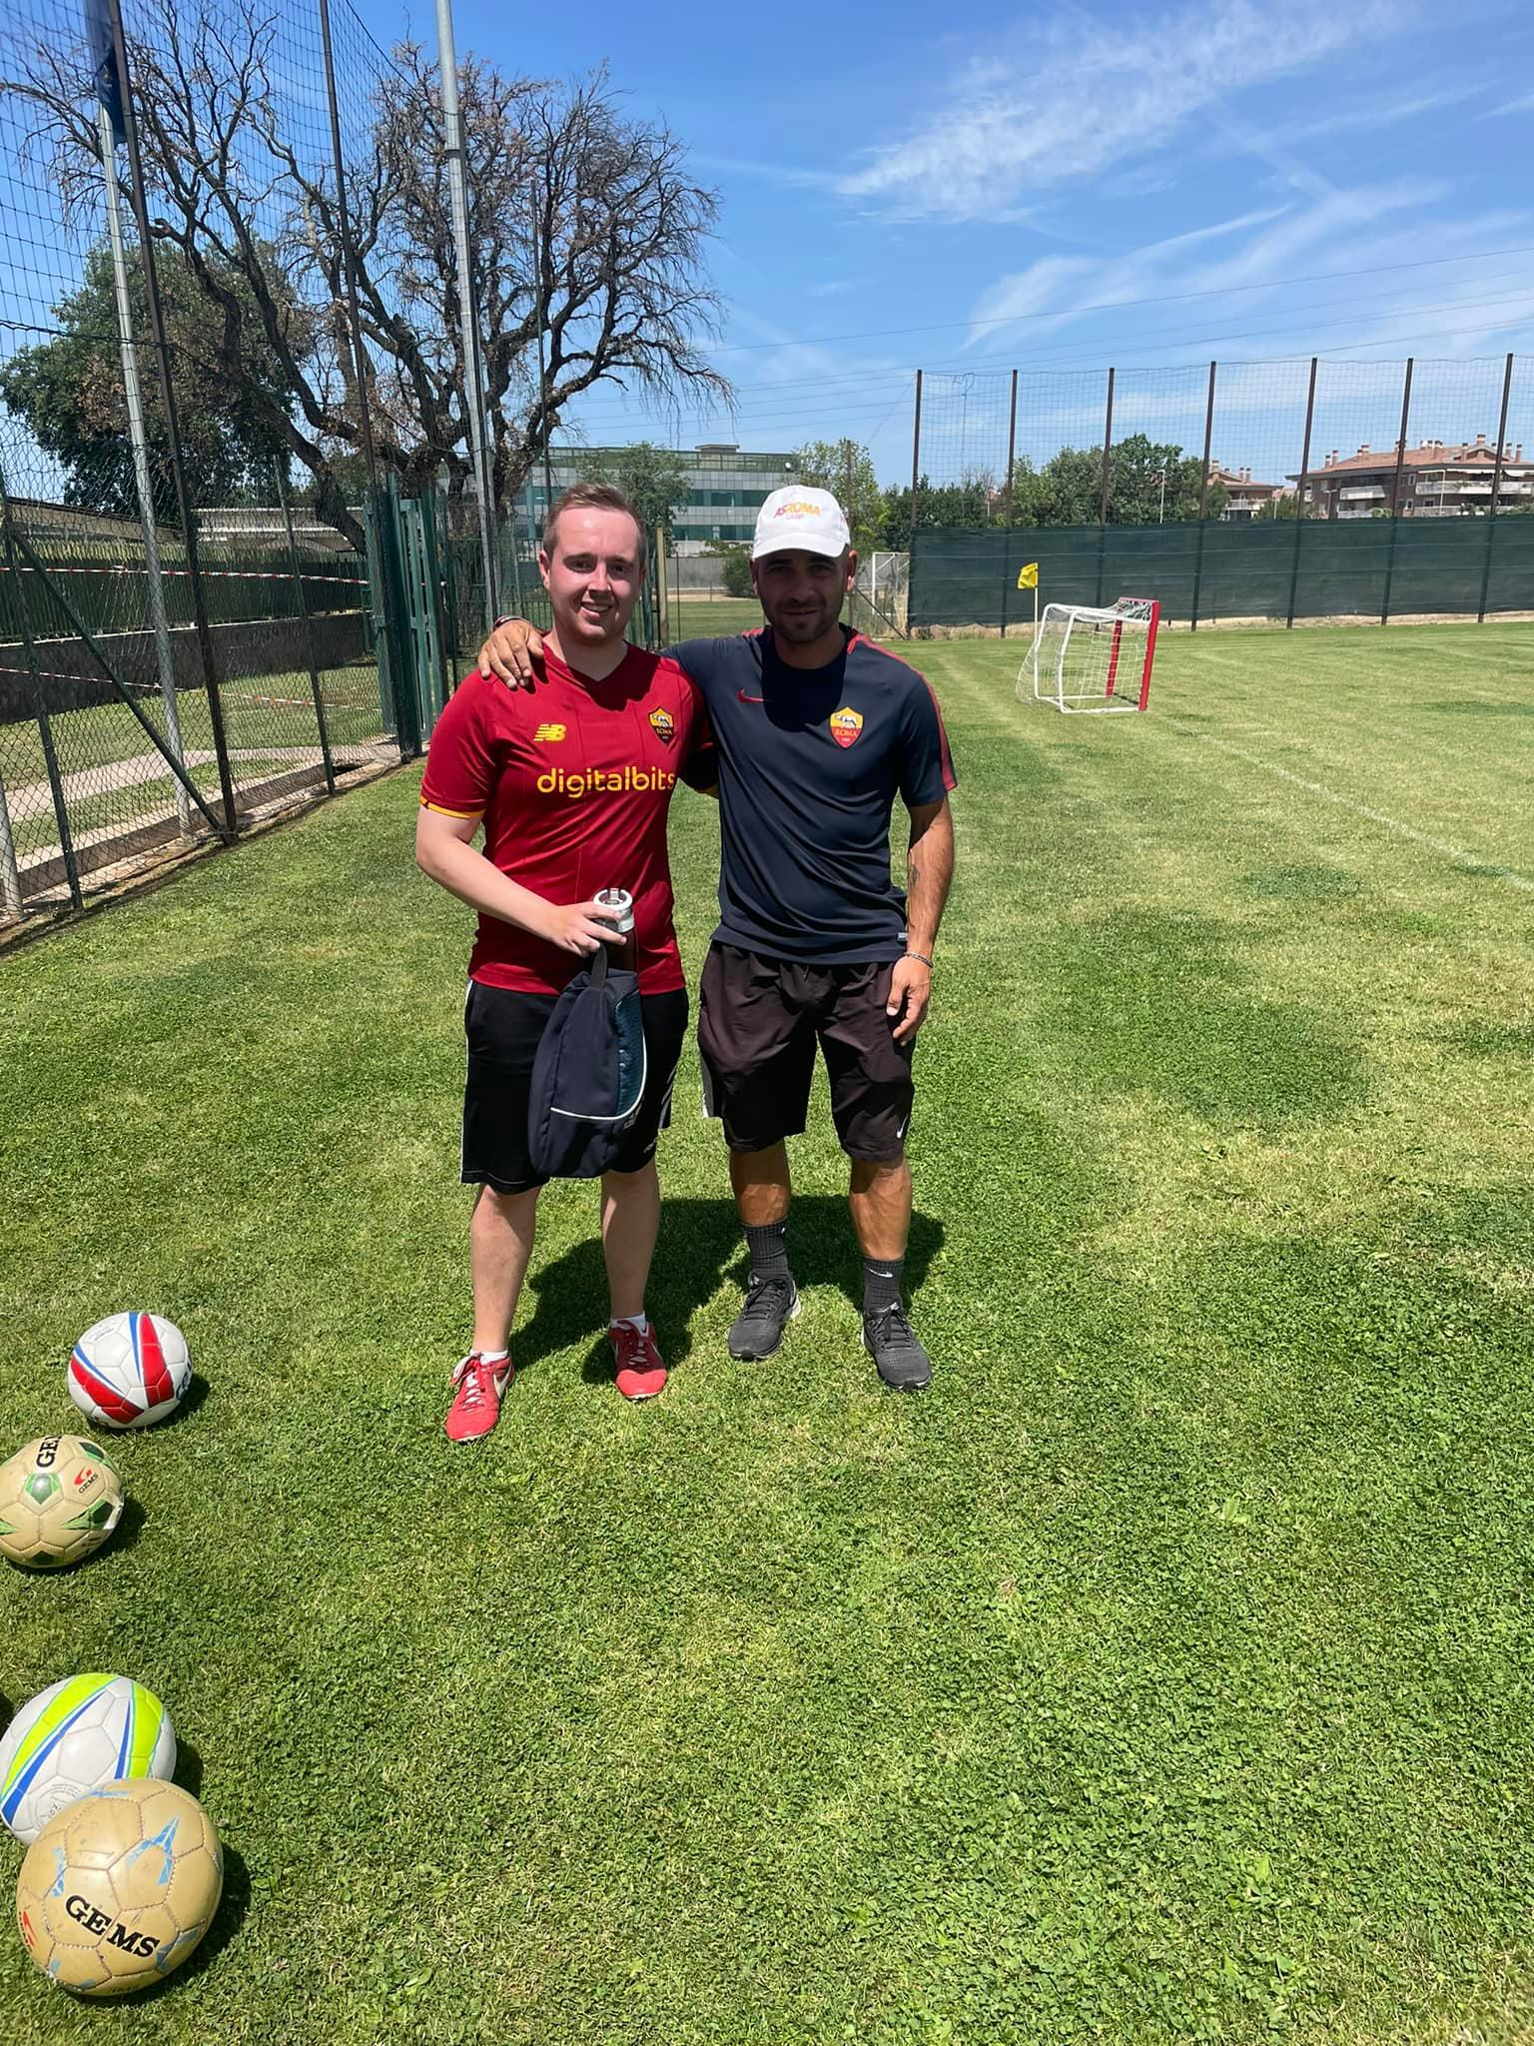 |  | sTRUAN eRRINGTON
Profile  I am a highly motivated, energetic and hardworking individual with aspirations to pursue a career within football coaching. I am a professional and well experienced coach with a wealth of knowledge regarding youth development within professional academy football and community settings. I have been privileged to experience football coaching in Scotland, Italy and the Netherlands.  PHONE:  +44 07401208119  LinkedIn:  Struan Errington  EMAIL:  struan-errington@hotmail.co.uk  Qualifications  UEFA C license Phase 1 & 2  S.F.A Children’s Coaching License.  S.F.A Goalkeeping Level 3.  S.F.A Football Psychology.  S.F.A Physical Preparation.  S.F.A 1.3 Children’s Coaching Award.  First Aid  Children’s Wellbeing in Football  Mental Health in Scottish Football  Safeguarding and protecting Children  Double Goal Sports Coach Award  Languages  Fluent English & currently learning Italian. |  | EDUCATION  University of the West of Scotland  2017 – 2022  MSc + Postgraduate Certificate Sport Coaching & Development.  WORK EXPERIENCE  Partick Thistle Football Club – Thistle Weir Youth Academy Coach  2015 – Present  Head coach for under 12, 11 & 13 age groups.  Assistant coach for under 14 & 16 age groups.  Partick Thistle Charitable Trust – Coach  2021- Present  Partick Thistle Youth Academy – Performance Analysis  2020- 2021  Rangers Football Club Youth Academy - Performance Analysis  2019–2020  Lanarkshire Street Futsal LTD - Futsal Coach  2019–2022          SKILLS  - Nine Years of football coaching experience.  - Strong understanding of youth development.  - Teamwork, adaptability and Leadership qualities.  - Excellent communication and people management.  - Good understanding of athlete psychology.  - Exceptional coaching sessions with attention to detail.  - Time management, organization & planning.  - Proficient I.T and Software skills.

Responsibilities

Partick Thistle Academy Coach:

As an academy coach, my main responsibilities are to:

- Create a learning environment and culture for players to express themselves and fulfil their potential.

- Plan, setup and organise training sessions in line with the club’s philosophy and academy technical components.

- Work co-operatively with the other academy teams and staff.

- Match preparation, set up facility and prepare the team prior to kick off.

- Conduct player/parent assessment meetings to discuss development progress throughout the season.

- Lead the Under 11/12 teams’ futsal programme.

- Assist John Paul Academy School of Football Program

Rangers Football Club / Partick Thistle Football Club - Performance Analysis

My time as a performance analyst with both clubs held similar responsibilities, including:

- Set up, manage and film academy games each week from Under 11s to Under 21’s and women’s first team.

- Tag and code games using NAC Sport and Sportscode software.

- Create highlights and tag moments in the game that are requested by the coaches.

Partick Thistle Charitable Trust – Coach

Alongside the academy, working with the club’s charitable trust involves coaching within the community:

- Host and coaching Holiday camps for all ages and abilities.

- Plan and deliver group and 1-to-1 sessions.

- Be inclusive and provide opportunity for kids to learn new skills and make friends.

- Create a fun environment for all ages to enjoy football.

- Represent the club well and try make a positive impact within the community.

- Manage and maintain all equipment and facilities.

